**FRESH BITES CATERING**

**PROJECT REPORT TEMPLATE**

**INTRODUCTION**

* 1. Overview

Zoho Books is an online accounting application that takes care of the accounting needs of your business. You can record, audit and analyze all financial transactions easily.

* 1. Purpose

Zoho Books is your one-stop platform for managing your accounting tasks and organizing your transactions.

**Problem Definition & Design Thinking**

2.1 Empathy Map

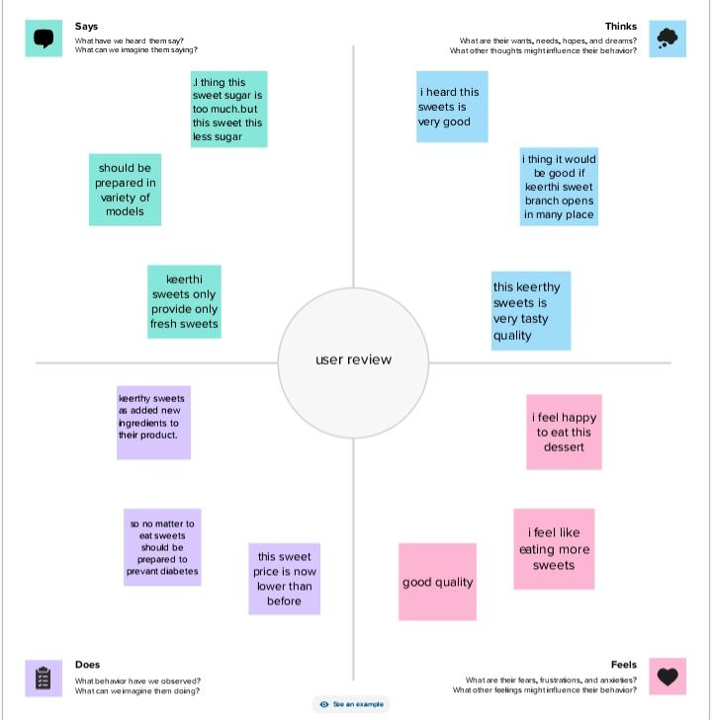

2.2 Ideation & Brainstorming Map

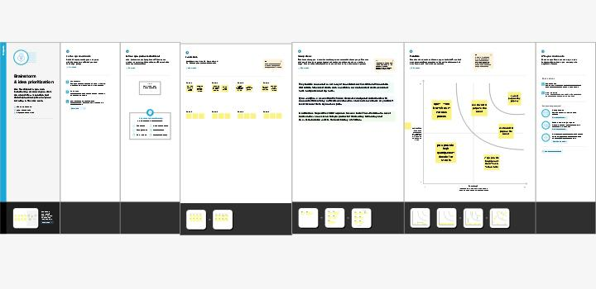

**RESULT**

**Output**

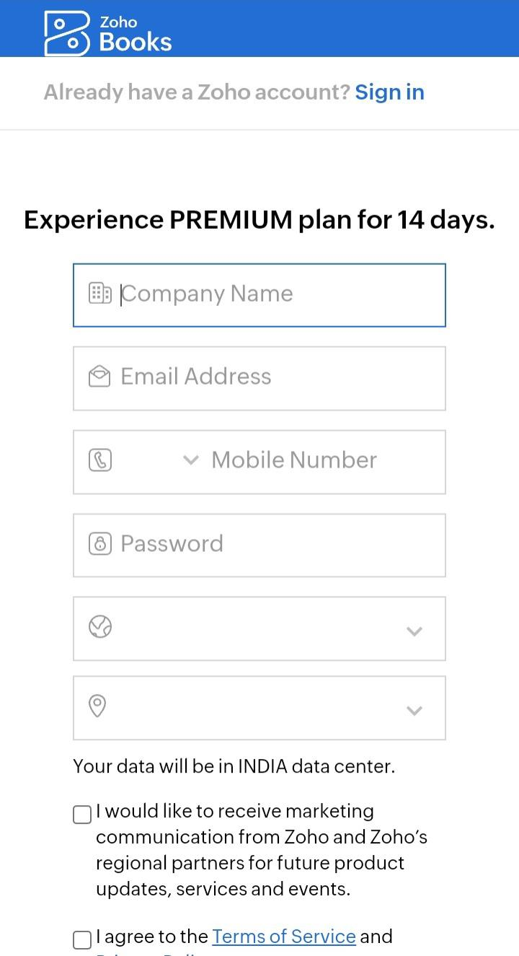**Item creation**

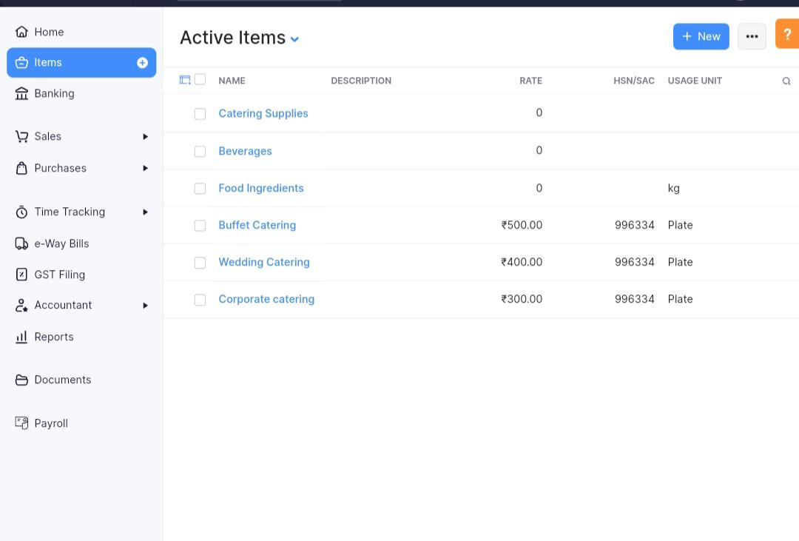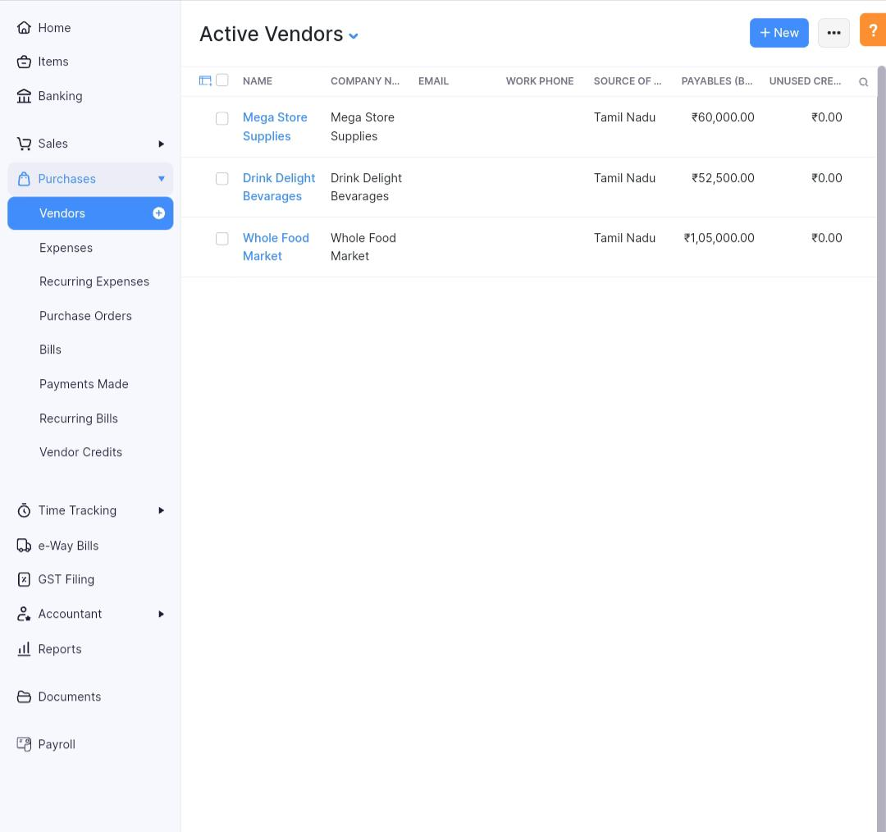**Vendor creation**

**Purchase order**

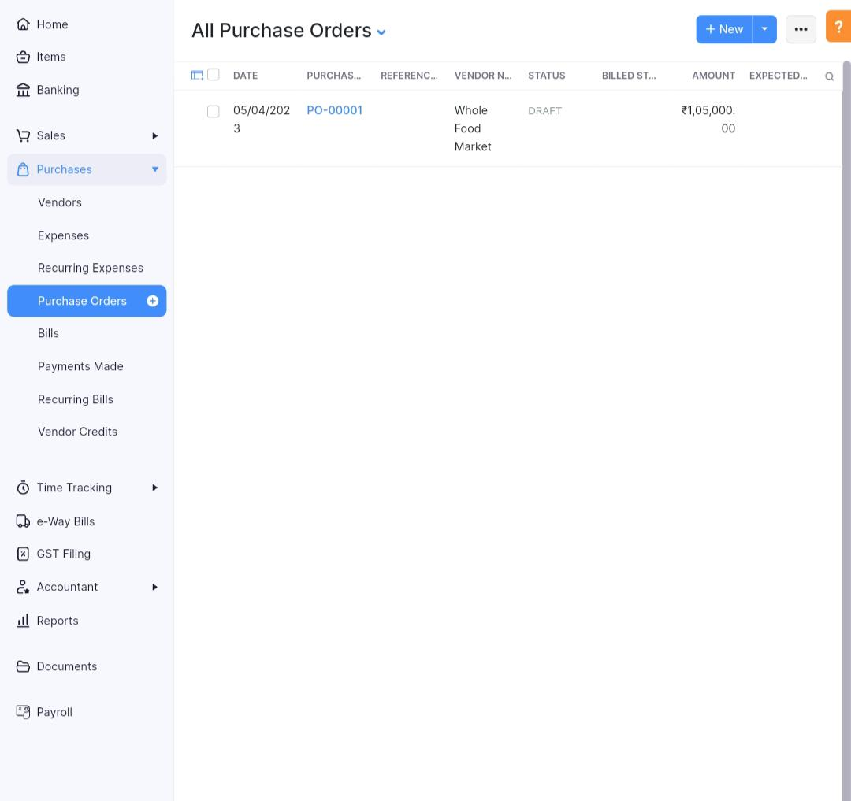**Sales order**

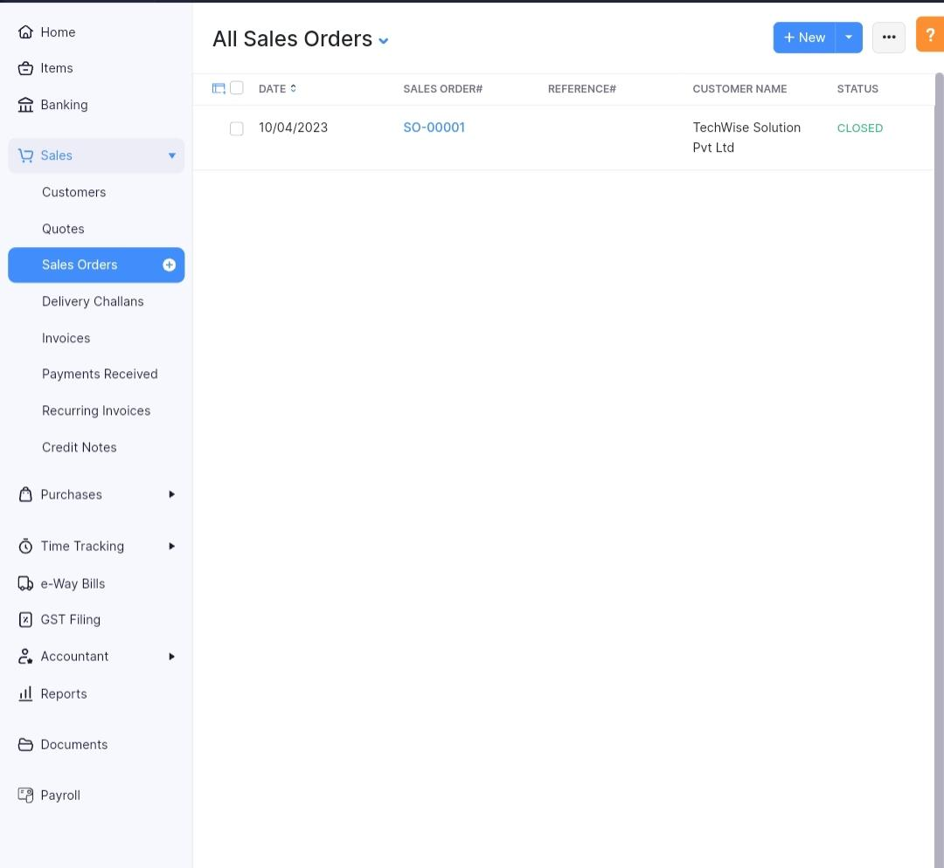

**Bank details**

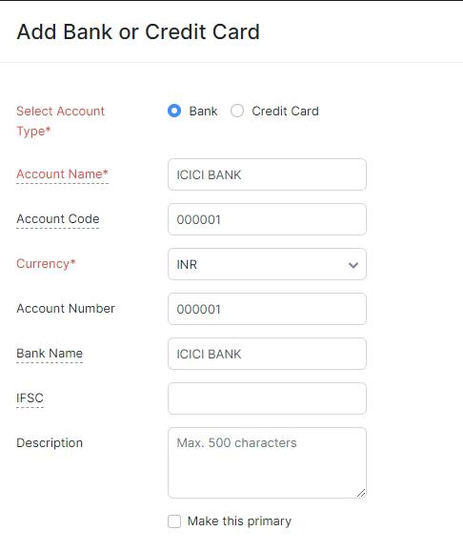

**Profit & lose account**

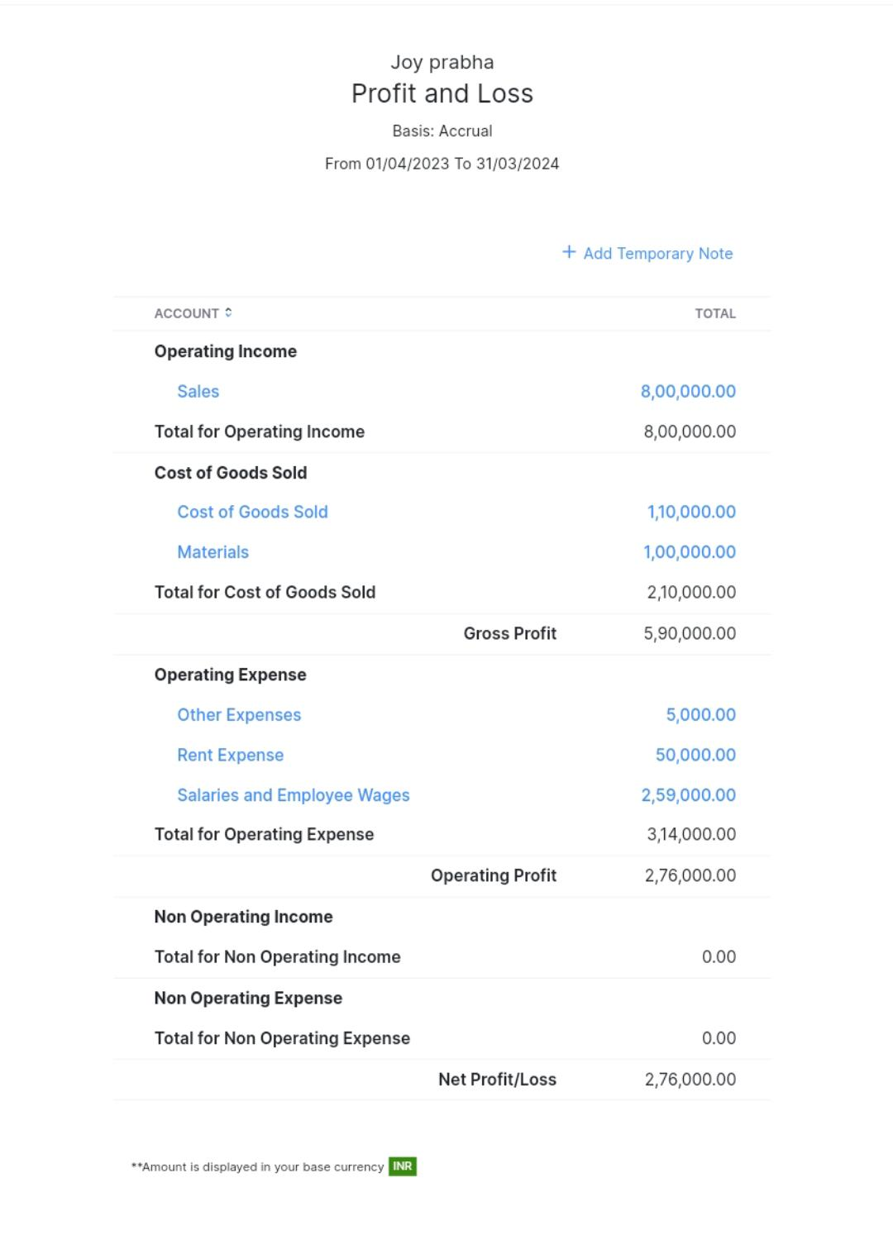**Balance sheet**

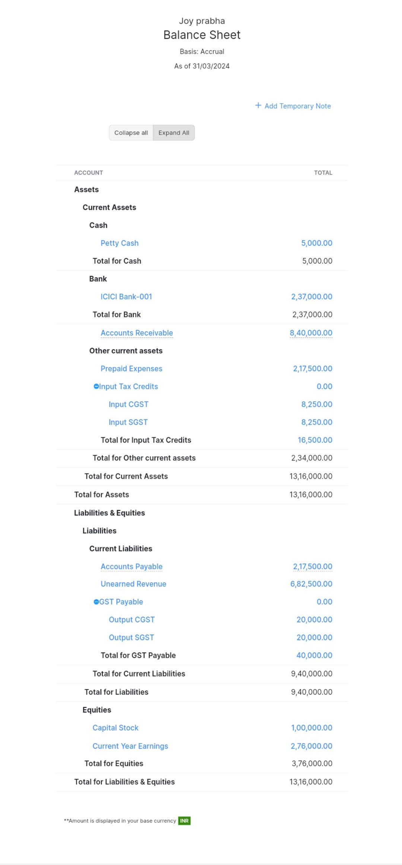

**GST**

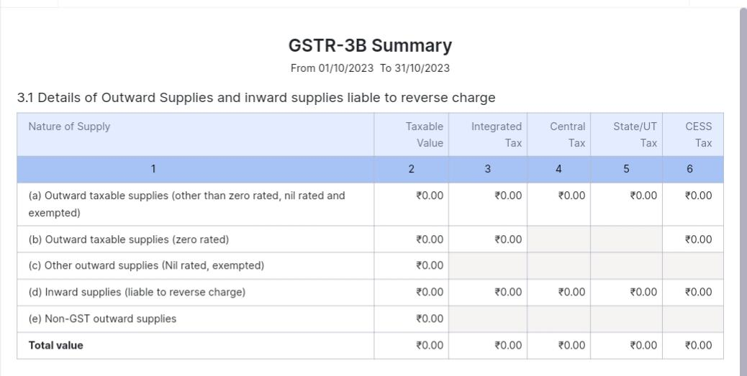

**Advantage & Disadvantage**

Advantage

* Invoicing And Billing. ...
* Online Payments. ...
* Expense Tracking. ...
* Project Management & Timesheets. ...

Disadvantage

* Monthly transaction cap. One significant Zoho Books limitation is the cap on monthly transactions. ...
* Multiple subscriptions for multiple businesses. ...

**Application**

This application used to maintain the company details and ledger account, profit and loss account and balance sheet of the company mega store supplies.

**Conclusion**

It is service the DELIVERY, COOKS, and SERVES FOOD on sit at a clients location.

**Future scope**

Preparing and storing food safety before during events, setting up all tables and food service areas with chairs, lines and dishes, serving food to guests at events. It also helped to reduce the work of the accountant to maintain account.

**Appendix**

Approved Development

Future Assessment

Plan of Development

Contactless Free Delivery and Pickup.

team16 <https://github.com/mtu121ucom020/preparation-and-maintence-of-zoho-books>-for-keerthi-sweets/commit/ff360b30f50dd1e606790821a76b9b3628b1d68d